**PRACTICAL – (8.1)**

**AIM: Write a program (using functions!) that asks the user for a long string function. Containing multiple words. Print back to the user the same string, except with the words in backwards order. For example, say I type the string: My name is Michele Then I would see the string: Michele is name My shown back to me.**

**PROGRAM:**

|  |
| --- |
| def reverse(string):  return ' '.join(string.split(' ')[::-1])  print(reverse(input('Enter The Name: ')))  print("\n20DCE019 - Yatharth Chauhan") |

**OUTPUT:**

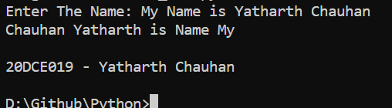

**CONCLUSION:** In this practical, we learned to Reverse a sentence without actually reversing the word.

**PRACTICAL – (8.2)**

**AIM: Write a password generator in Python. Be creative with how you generate passwords - strong passwords have a mix of lowercase letters, uppercase letters, numbers, and symbols. The passwords should be random, generating a new password every time the user asks for a new password. Include your run time code in a main method.**

**PROGRAM:**

|  |
| --- |
| import string  import random  a = int(input("Enter Length of password: "))  all = string.ascii_lowercase+string.ascii_uppercase + \  string.digits+string.punctuation  def passwordGen(size):  return ''.join(random.choice(all) for _ in range(size))  print(passwordGen(a))  print("\n20DCE019 - Yatharth Chauhan") |

**OUTPUT:**

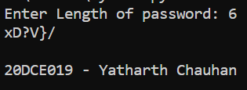

**CONCLUSION:** In this practical, we learned about How to use Random Library to Generate Password.